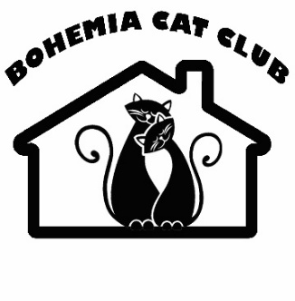 | BOHEMIA CAT CLUB, z.s.  Člen WorldCatFederation  Hlízov 224, 285 32Hlízov, ČR  IČ: 45 247 269  Bankovní spojení: 2101005600/2010  IBAN: CZ0220100000002101005600  BIC/SWIFT: FIOBCZPPXXX | 
APPLICATION / MEMBER REGISTRATION
Name and surname: ……………………………………..……………………………….……..…….................
Date of birth:……………………………………………………………….………………………………………..
Address:………………………………………………………………………………..…….…......................
Telephone: …………………………………………………………………………………..….………........................
E-mail………………………………………………………………………………………..…….….................................
Name of registered WCF cattery, or other international cat breeders' organization:
……………………………………………………………………………………………………….…...................
Breeds of cats:………………………………………………………..…………………....
Number of breeding cats: …………………………………………. Neutered cats:………………………..………...
I apply for membership in BohemiaCatClub, z.s. I have carefully read the Club Statutes, Breeding Rules, Member Code of Ethics, related regulations and under take to comply with them.
I amsending a membershipfee of: 700 CZK to theclubaccount
Consent to the management, processing and storage of personaldata
In accordance with the General Data Protection Regulation (GDPR) - Regulation (EU) 2016/679 as amended, I hereby give my consent to the management, processing and storage of personal data provided to Bohemia Cat Club z.s., with its registered office at Hlízov 224, 285 32 Hlízov, for the registration of members and breeding records, as well as for the needs of the WCF (WorldCatFederation), of which BohemiaCatClubis a member.
I agree - I do notagree* to the publication of my name and the name of the cattery in the list of members on the Bohemia Cat Club website.

On……………………… date……………………….. signature……………………………….

